E-Commerce Customer Churn Prediction
Data Analysis & Machine Learning Case Study
Analyzed 5,630 e-commerce customer records to identify churn drivers and built a Random Forest model that flags at-risk customers with 97% accuracy and 0.997 ROC-AUC — correctly catching 82% of customers who actually churned while keeping false alarms minimal (97% precision).

Approach
- Cleaned data: imputed missing values (median, ~4.5% affected columns), verified no duplicates, and caught/fixed inconsistent category labels (e.g., “Mobile” vs “Mobile Phone”) that were silently splitting the churn signal.
- Explored the data to find behavioral drivers of churn, using distribution plots and churn-rate breakdowns across both numeric and categorical features.
- Engineered features (one-hot encoding, scaling) and built a stratified 80/20 train/test split to ensure honest evaluation on unseen data.
- Trained and compared three models — Logistic Regression, Gradient Boosting, and Random Forest — using precision, recall, F1, and ROC-AUC rather than accuracy alone, since only 16.8% of customers in the dataset churned.

Key Insight
Churn is overwhelmingly concentrated among new customers: churn risk peaks sharply near zero tenure and drops off within the first few months. Cashback amount, complaint history, and delivery distance are secondary but meaningful drivers — all confirmed independently by the model's own feature importances.
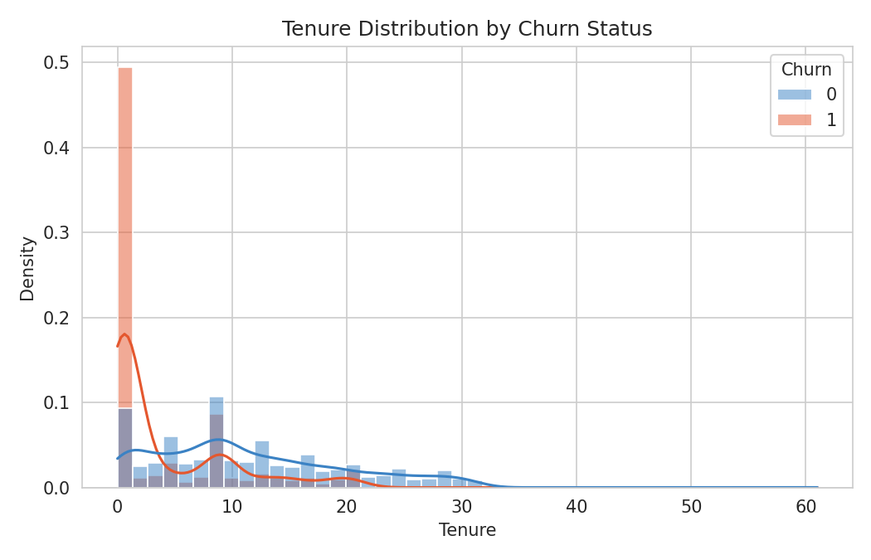
Churned customers cluster heavily at low tenure.

Model Results
Model | Precision | Recall | F1 | ROC-AUC
Logistic Regression | 0.77 | 0.55 | 0.64 | 0.886
Gradient Boosting | 0.82 | 0.67 | 0.74 | 0.944
Random Forest (best) | 0.97 | 0.82 | 0.89 | 0.997

Business Recommendations
- Concentrate retention efforts on the early customer lifecycle (onboarding, first-order follow-up), where churn risk is highest.
- Use targeted cashback/incentive offers for new or disengaging customers.
- Route customers with complaint history to proactive retention outreach.
- Deploy the Random Forest model to score active customers periodically and prioritize the highest-risk segment for intervention.
Tools: Python · pandas · scikit-learn · seaborn/matplotlib · Jupyter Notebook

